Lifting of the Fukuoka Corona Alert and future response
As of October 11, 2021
On October 11, The Fukuoka Prefectural Government's Corona Task Force held a meeting and decided to lift the "Fukuoka Corona Alert" that is currently in effect will be lifted on Thursday, October 14.
As a result, the current request to restaurants and bars to shorten business hours and refrain from using karaoke facilities will be lifted as of October 14.
It is necessary for all of us to remain vigilant, to be cautious, and to practice basic measures to prevent the spread of infection, so that society can prevent it from spreading again. We would like to ask for the cooperation of all prefectural residents and businesses from October 15 onward, as follows, so that we will not be asked to refrain from going out or shorten our business hours again.

Request to Prefectural Residents
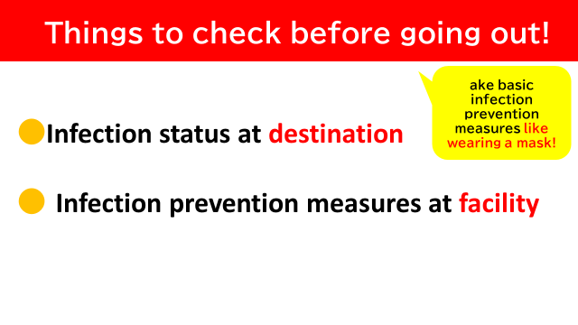
When you go out, please take basic infection prevention measures such as avoiding the three “Cs”, wearing a mask, and washing your hands, carefully check the infection status of your destination and the infection prevention measures of the facilities you use. If you have a fever, avoid going out.
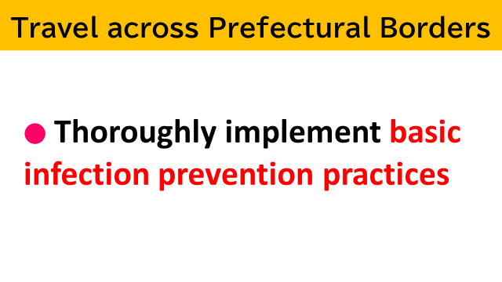
When traveling across prefectural borders, please take basic measures to prevent infection, such as avoiding the three “C”s.
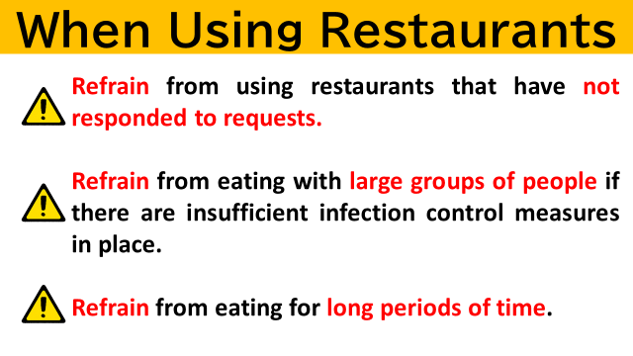
In the case of eating and drinking, please choose restaurants with thorough infection prevention measures, such as those with infection prevention certification.
Regardless of the number of people, if infection control measures are not sufficient, the risk of infection increases. Especially, when eating in large numbers, it is easy to become loud and droplets can easily fly, so please comply with the prefectural government's "Guidelines to Avoid Infection Risk while at Restaurants" and refrain from eating if infection control measures are not sufficient. (See Appendix 1, "Guidelines to Avoid Infection Risk while at Restaurants")
Please refrain from eating for longer than two hours, as it is easy to become loud.
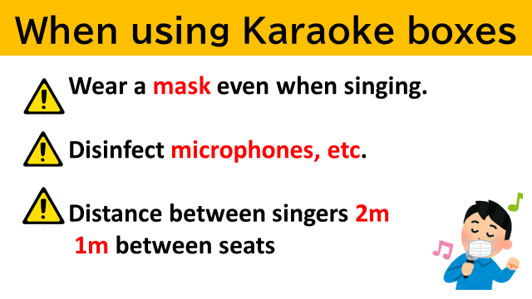
Please wear a mask when singing in a karaoke box, and keep a distance of at least 2 meters from the person singing and at least 1 meter between seats. Please disinfect microphones and other equipment each time you change users.

